The Water Runners' epic harmonies will sweep you off your feet

Dominic Unwin

Latest News
Audiences could be forgiven for thinking they'd been transported back in time when local band The Water Runners take to the stage.
The five-part harmony band is a rollicking blend of Aussie folk, roots and a bit of bluegrass thrown in and have been captivating listeners with their epic storytelling.
Based out of Kiama and Gerringong, the Water Runners are made up of John Littrich (guitar/vocals), Neil McCann (banjo/mandolin/vocals) and younger musicians James Turk (double-bass), Bowral's Danita Harris (violin) and Dom Littrich (percussion).
Across their three albums, The Water Runners have become famous for their ability to tell a story, a feature well suited to their epic harmonies.
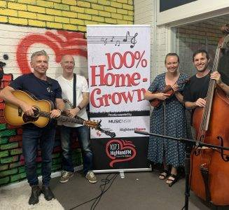
The Water Runners: (L to R) John Littrich, Neil McCann, Danita Harris and James Turk. Picture: supplied
Speaking to Highland FM's Lea Steed after being announced as the station's January Artist of the Month, John said they had worked hard to master the art.
"It's something we've wanted to work on [harmonies] for that storytelling in our songs," he explained.
"We want those vocals to be out there and to be heard. It's not something you hear a lot of bands do. Most have a lead and backup but when you get three or four people together doing harmonies, it's a nice touch.

"When we get to the part where the harmonies are required, Neil and Danita are great at picking out various notes of the harmonies and so they make sure each person is singing different harmonies to me which makes it blend together well.
"It's a lot easier to do recording compared to live. We do get a lot of comments about our harmonies when we play live so we do work hard at it."
Their most recent release, Further Down the Road, has been out for a few months. Featuring upbeat tunes such as the title track and solemn ballads about some darker chapters like Minnamurra, which tells of the 1818 massacre of Aboriginals in the Illawarra, it's a hell of a ride.
"We wanted to use that old-Bluegrass style and apply it to our local area rather than singing about historical events in England or America," he said.
"Some of the stories like Minnamurra of course concern the terrible things that happened to our First Nations people here, that a lot of people might not know about.
"Stories like that need to be told. Then we've got something like Jamberoo Mountain Blues which is a bit of fun."
John explained the process of creating the album, one that was typical of the times.
"It's been a year since we headed up to Sydney to record the album," he said.
"We only had five days to pump out 12 songs, in fact we only came up with the title track the night before our last day or recording because we thought 11 is an odd number, well literally.
"By the time we were happy with the mixing it was March, April and we released a couple as singles and then we were all set to do a great big live launch and a string of shows in July.
"Of course, everything went pear-shaped. It was a shame but we were lucky to be able to do some online shows.
"We had a string of live shows late last year so looking forward to plenty of shows in 2022!"

